**Beautiful Premium Quality Wild Flora Large Metal Wall Art**

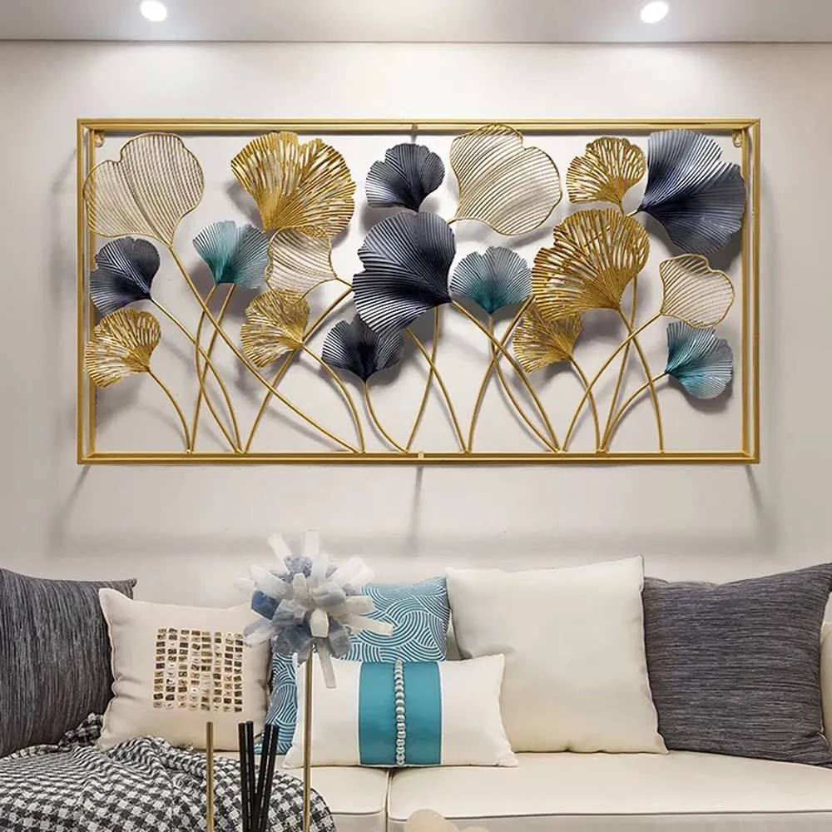Beautiful premium quality wild flora large metal wall art is an exquisite and striking statement piece that brings the beauty of nature into your home with exceptional craftsmanship. Featuring an array of wild flora, such as delicate flowers, leaves, and stems, the intricate design captures the natural world in stunning detail. Crafted from high-quality metal, the piece is often finished with rich textures and elegant tones like matte gold, silver, or copper, adding depth and sophistication. Its large scale makes it perfect for spacious living rooms, dining areas, or foyers, where it can serve as the centerpiece of your decor. This wall art blends artistry and nature, creating a timeless, luxurious atmosphere in any room.